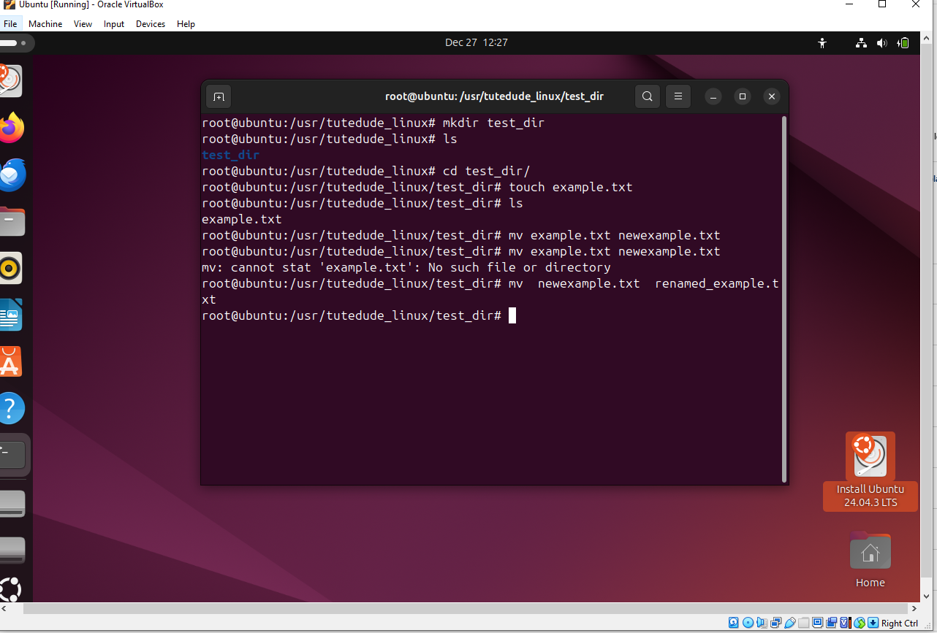

- Explanation: mkdir command is used to create folder then change directory using cd command move to that folder then create file using touch command, move command mv is used to rename the file we move the file in same directory using new name .

2. Viewing File Contents
Use cat to display the contents of /etc/passwd.
Display only the first 5 lines of /etc/passwd using head.
Display only the last 5 lines of /etc/passwd using tail.

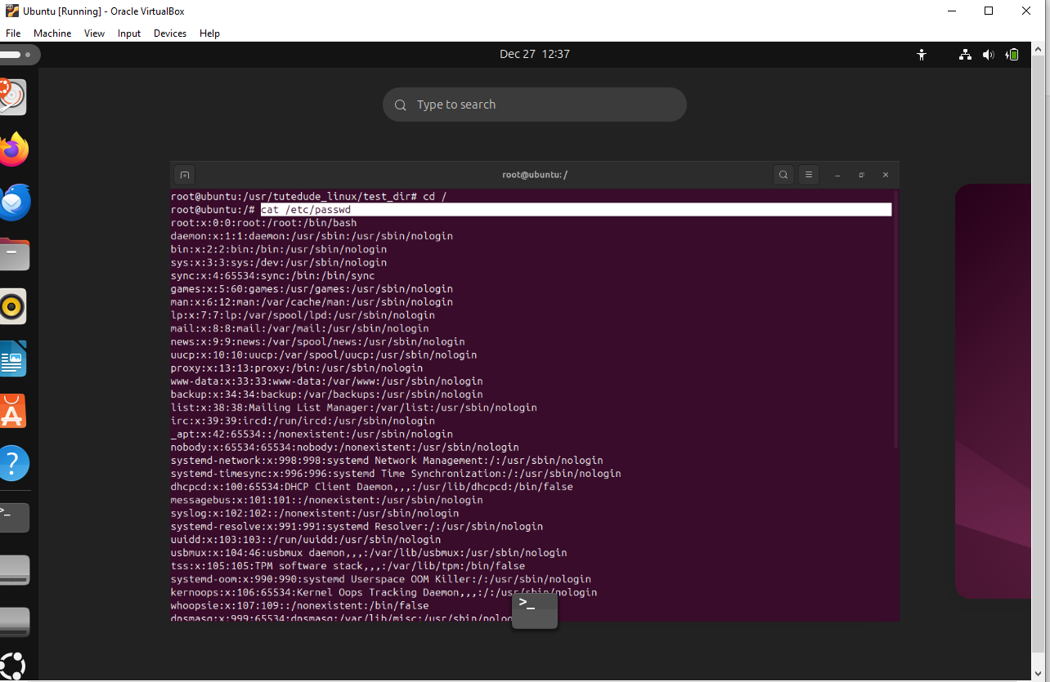
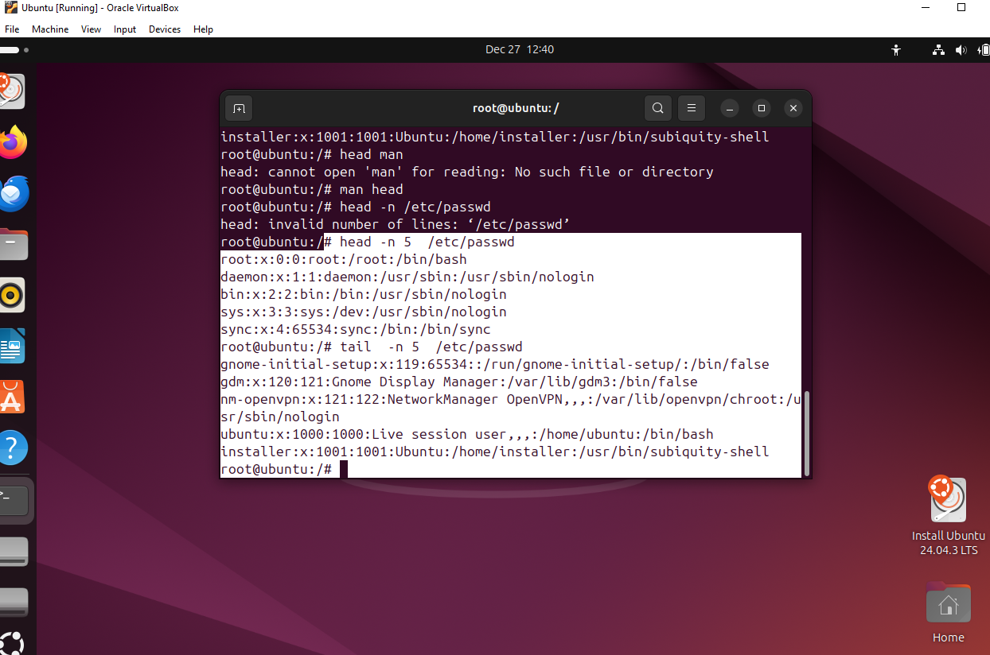

Explanation : First we move to root directory using [ cd / ] cmd then print content of file using cat cmd ,[ head -n 5 ] option n used to print first n line similarly tail cmd used to print last n line here n value is 5

3.
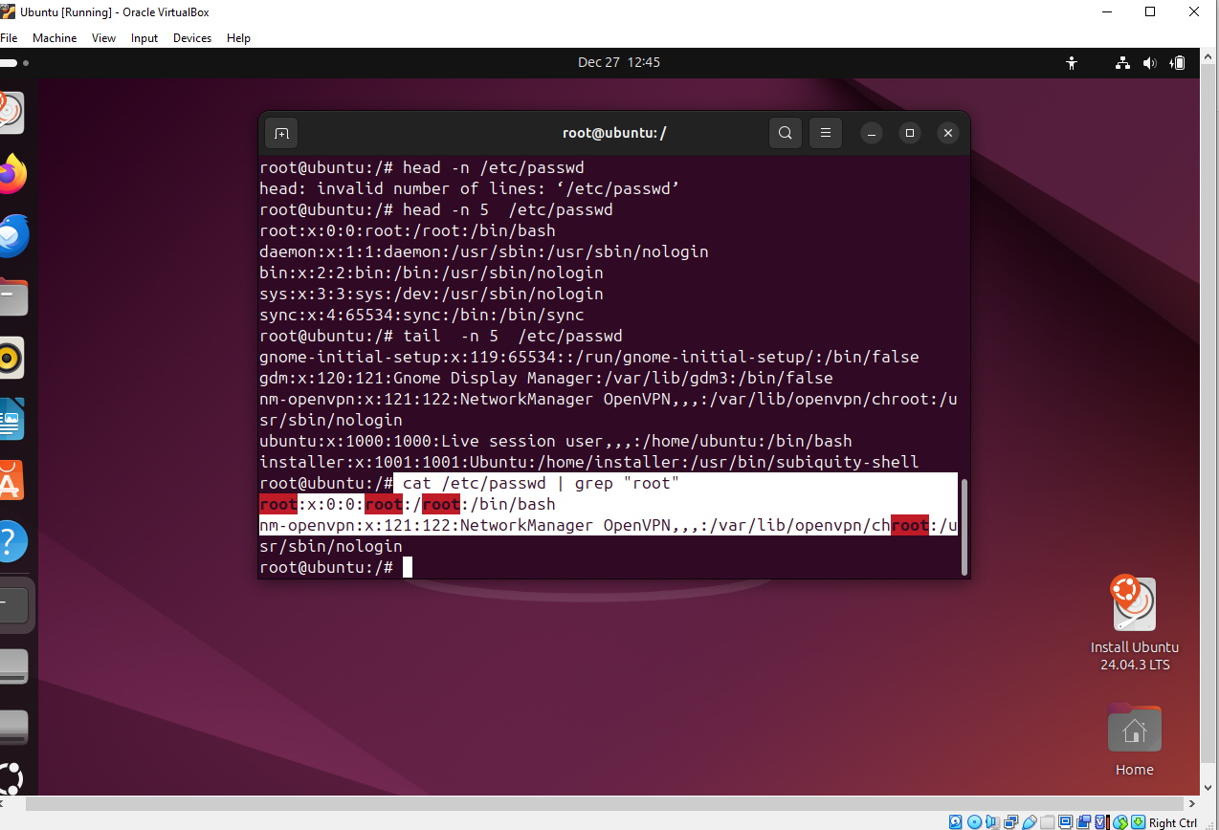

Explanation : we use [ | ] to connect two command we pass the result of cat cmd to grep and it filter out the all string match to given string

4.
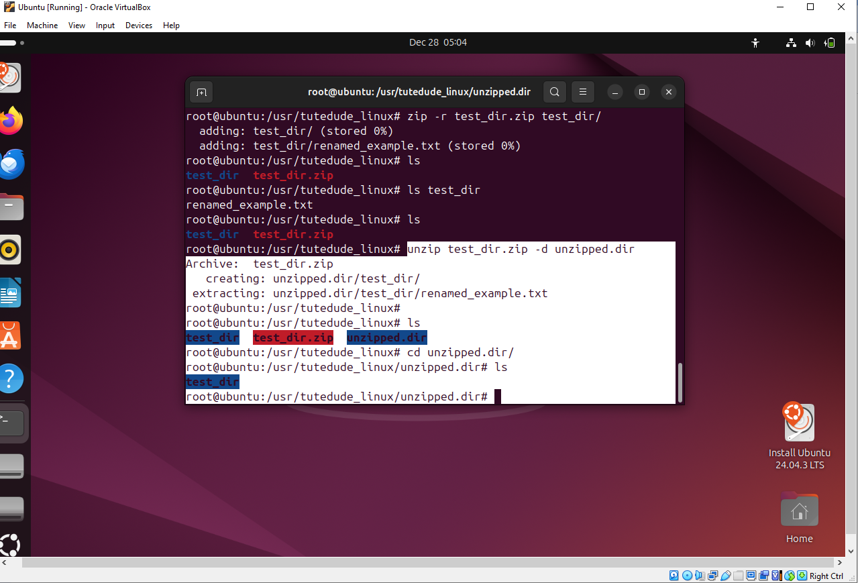
Explanation: [ unzip filename.zip -d /path/to/destination_folder ] unzip a file/folder at different location use d option

5.
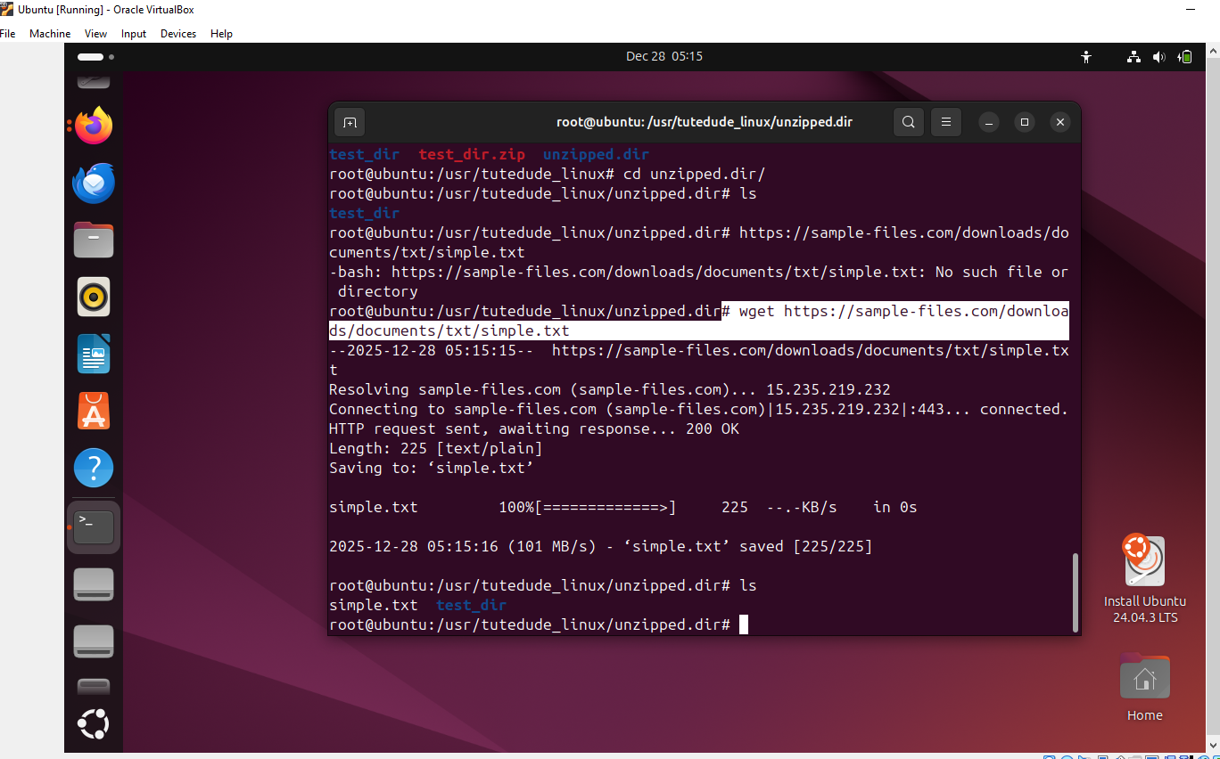

Explanation : wget command need path/download link of file for download it

6.
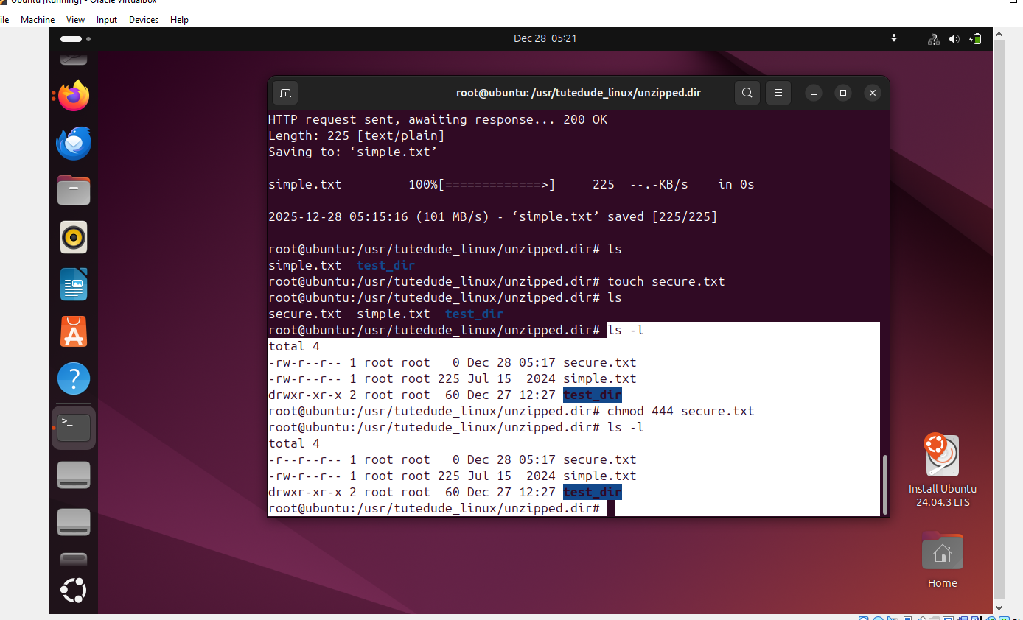
Explanation: ls -l give list of all file in current folder with type of permission
chmod 444 filen_name 4(read only permission) [444 means owner, group,other]

7.
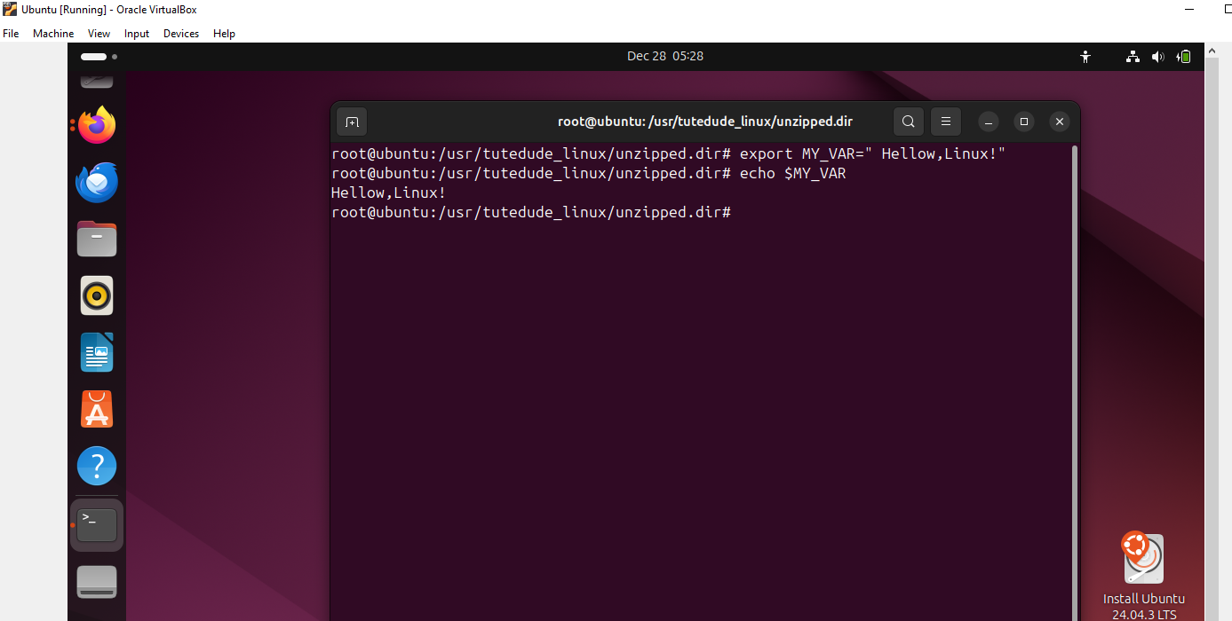
Explanation : export cmd used to set global variable where echo cmd print value of variable or on console/screen

